

PIAB USER MANUAL

**Prepared by: IT Department, Krishibid Group**

Content

Introduction 2

Description of the System 2

1. PIAB Login Page 3

2. Dashboard 4

**2.1 PIAB Home Page** 4

2.1.1 Change Password 4

2. Member Information 5

**2.1 Self Company Information:** 5

**2.2 Add New Member** 6

**2.3 Members Contact Information** 6

3. Customer Information 8

**3.1 Add New Customer** 8

**3.2 My Customer** 8

**3.3 All Customer List** 10

# Introduction

The Krishibid Group has initiated development of Enterprise Resource Planning (ERP) with the essence of establishing an effective database, to address and strengthen existing information system through coordinating and networking of existing human resource data collection systems. Krishibid consulted a team of experts, department of IT of Krishibid Group to take the responsibility of developing, implementing and maintaining HRMS system in this organization. **As for any big system development the process is not an overnight thing.** HRMIS is evolving, though with a remarkable speed, the inputs of stakeholders are all time required. This manual outlines the systematic procedures for accessing and using various parts of the system.

In case you do not get the assistance, you expected from the manual please consult your system administrator or any person authorized to work as the member of the helpdesk team at your organization.

# Description of the System

The following part is intended to give user an insight on how to use the system and access different features and system components.

# 1. PIAB Login Page

Open the browser and type the following address: http:// [http://192.168.0.7:9](http://192.168.0.7:90/)8 then a page similar to the one shown in the image below will be displayed whereby a user will be required to type in their correct **username** and **password**. This system works best with Google Chrome, Mozilla Firefox, Microsoft Edge or Opera browsers. From here on, the use of the word “browser” will refer to above mentioned web browsers only.

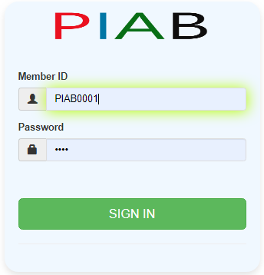

**Figure: 01 PIAB Login Page**

**Logging on ERP System:**

* **Step-1:** Provide Valid **Username and Password. For Username Always Provide your Member ID. (Example: PIAB MemberID : PIABXXXX , Password: XXXXXX).**
* **Step-2:** Click on **‘Sign In’** button for go to Home page of PIAB.

# 2. Dashboard

## **2.1 PIAB Home Page**

On successful login, a user is directed to the Home Page which consists of the main menu on the left side named dashboard. At the top most part of the system you will have on your left a home icon to denote the home page, a help button- which contains this help manual and the Member Id of the user currently accessing the system.

The following figure (Fig-02) shows menu bar and home page.

**Figure: 02 PIAB Home Page**

* **Step-01:** Click on the Dashboard section under main navigation panel of PIAB Home Page.

### 2.1.1 Change Password

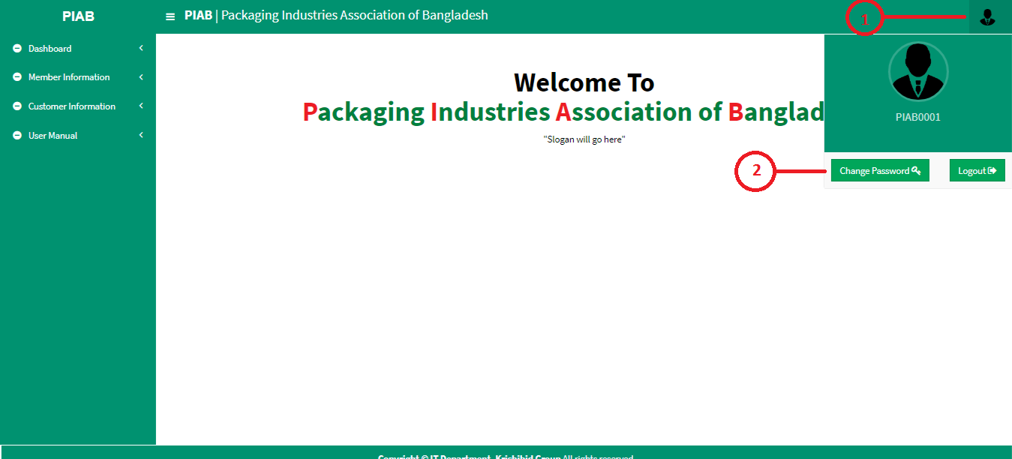In the instance where a user can change his password.

**Figure: 03 Members Password Change Page (1)**

* **Step-01:** Click on the **PIAB Member ID (PIABxxxx)** section under main navigation panel of PIAB software.
* 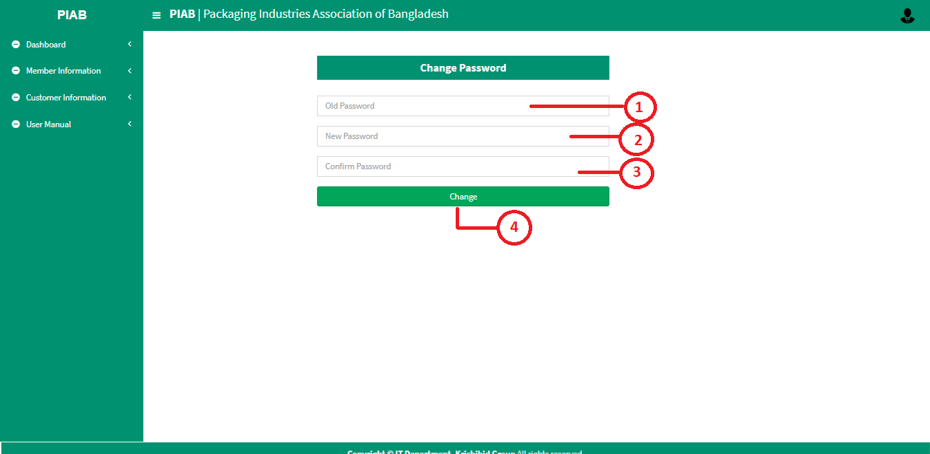**Step-02:** Click on “**Change Password**” button for changed members’ password.

**Figure: 04 PIAB Members Password Change Page (2)**

* **Step-02:** Enter “**Old Password**”, “**New Password**” and “**Confirm Password**” and click on “**Change**” button for changed member’s current password and new password will be automatically generated. After logout from the PIAB member must enter updated password for entry on ERP.

# Member Information

## **2.1 Self Company Information:**

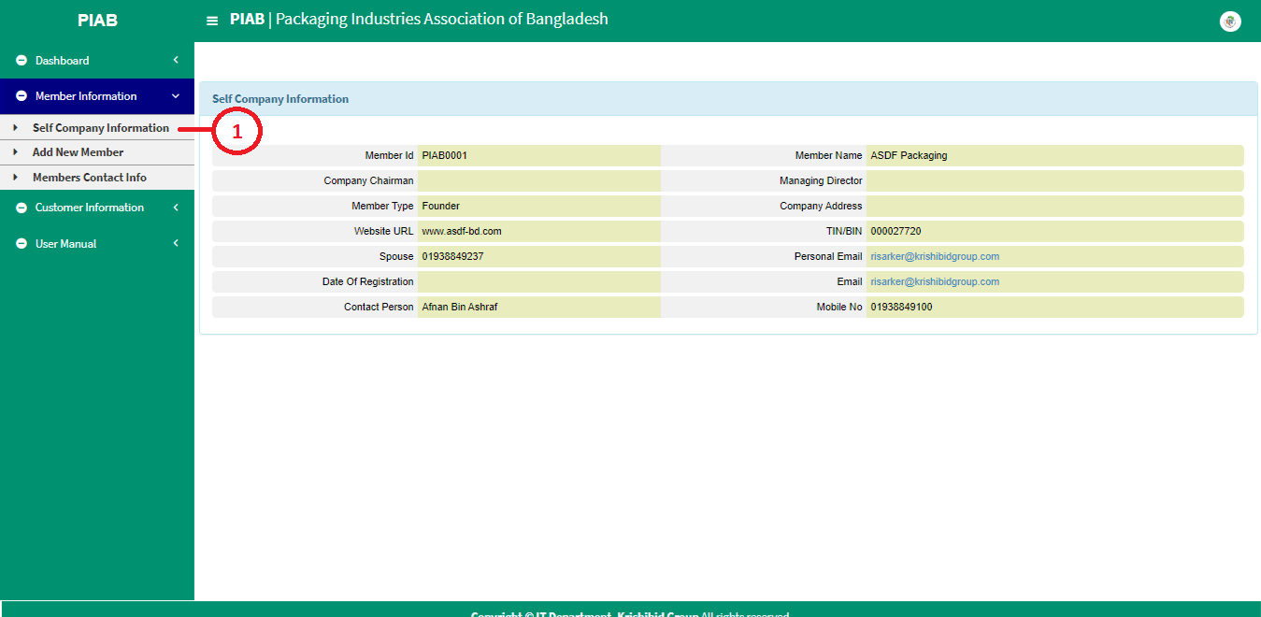The following figure (Fig-05) shows options for PIAB Me.

**Figure: 05 PIAB Self Company Information**

* **Step-01:** Click on the **Self Company Information** section under **Member Information** option. The following figure (Fig-05) shows the **Self Company Information Detail of PIAB**.

## **2.2 Add New Member**

The following figure (Fig-06) shows options for PIAB new member form.

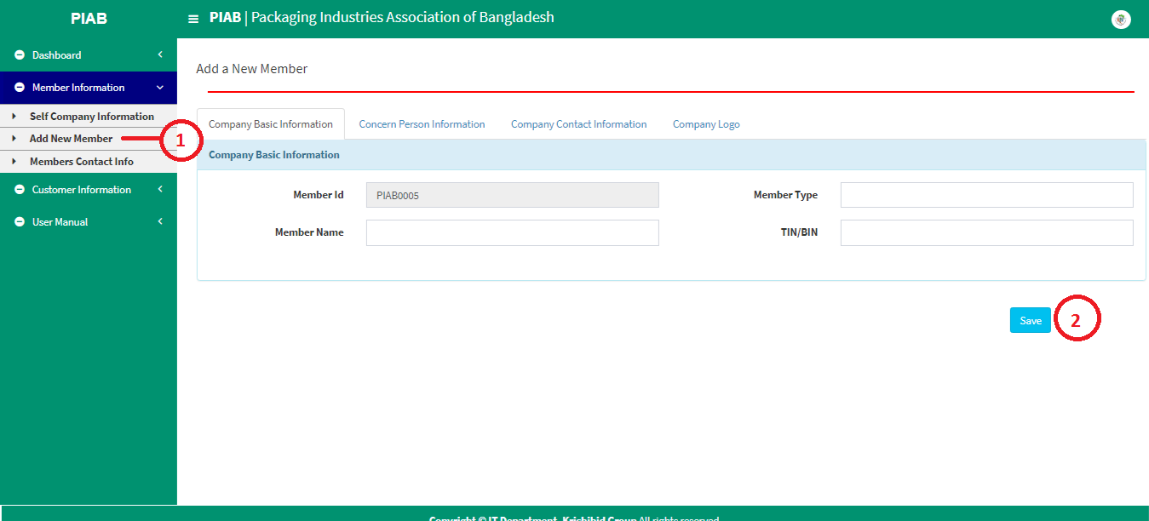

**Fig: 06 Add New Member Form**

* **Step-01:** Click on the **Add New Member** section under **Member Information** option. The following figure (Fig-06) shows the new members information form including Company Basic Information, Concern Person Information, Company Contact Information and Company Logo Details and Save new Member on PIAB.

## **2.3 Members Contact Information**

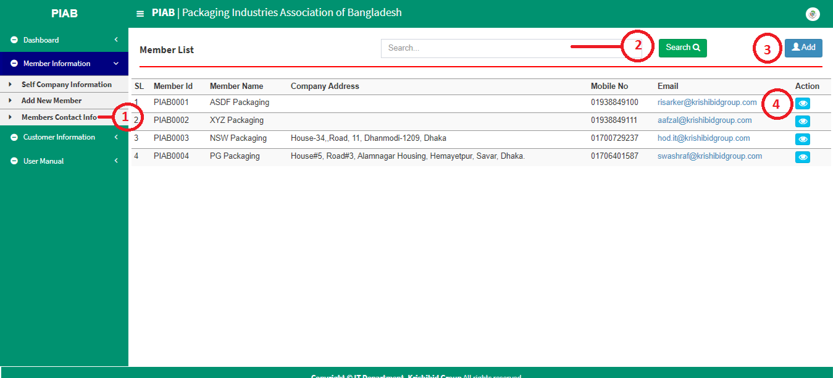The following figure (Fig-07) shows options for PIAB Members contact information.

**Fig: 07 Members Contact Information**

* **Step-01:** Click on the **Member Contact Info** section under **Member Information** option. The following figure (Fig-07) shows the PIAB Members List form.
* **Step-02:** Enter any **“Member Id” or “Name” or “Name” or “Company Address” or “Mobile No”, “Email”** in the search section and click on button to search any member.
* **Step-03:** User can add any “**New** **Member”** by click on Add button. The following figure (Fig-06) shows the New Members Entry page.
* 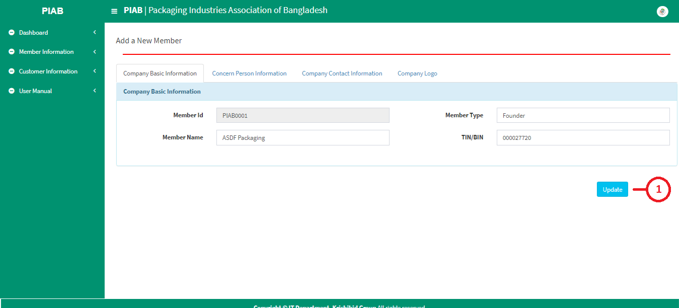**Step-04:** Click on Detail information in case of any update needed for Previous Member.

**Fig: 07.1 Members Contact Info Modification**

* **Step-01:** The following figure (Fig-07.1) shows the members information form including Company Basic Information, Concern Person Information, Company Contact Information and Company Logo Details. User can update previous Member information on PIAB.

# 3. Customer Information

## **3.1 Add New Customer**

**Fig: 08 Add New Customer Info**

* **Step-01:** Click on the **Add New Customer** section under **Customer Information** option. The following figure (Fig-08) shows the customer information form including Company Information, Concern Person and Information and Payment Information details. User can add new customer by click on save Button.

## **3.2 My Customers**

**Fig: 09 Customer List**

* **Step-01:** Click on the **My Customer** section under **Customer Information** option. The following figure (Fig-09) shows the Customers information.
* **Step-02:** Enter any **“Customer Type” or “Name” or “Contact Person” or “Mobile No”, “Email”** in the search section and click on button to search any customer info.
* **Step-03:** Click on the **Add New Customer** section under **Customer Information** option. The following figure (Fig-08) shows the customer information form including Company Information, Concern Person and Information and Payment Information details. User can add new customer by click on save Button.
* **Step-04:** The following figure (Fig-09) shows the customers information form including Company Basic Information, Concern Person Information, Concern Person and Information and Payment Information details. User can modify previous customer information on PIAB.
* **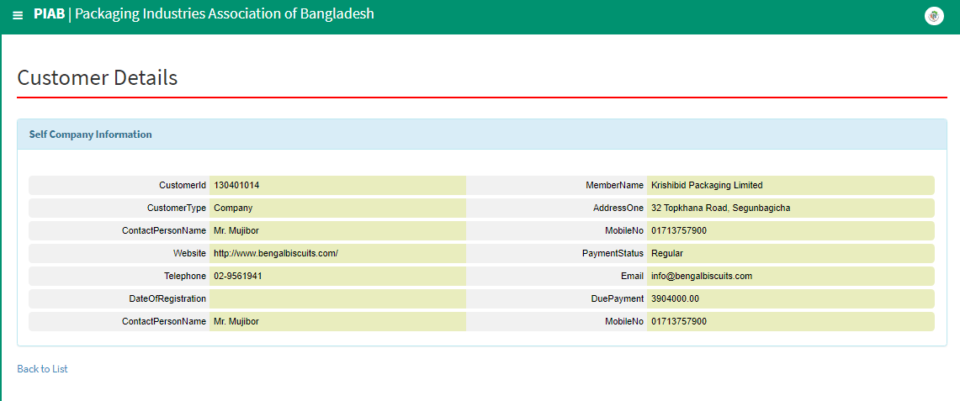****Step-05:** Click on the detail button. The following figure (Fig-10) shows the **Detail of** **Customer Information on PIAB**.

**Fig: 10 Customer Details**

## **3.3 All Customer List**

**Fig: 11 All Customer List**

* **Step-01:** Click on the **All Customers** section under **Customer Information** option. The following figure (Fig-11) shows the Customers information based on in details.
* **Step-02:** Enter any **“Customer Name” or “Type” or “Member Name” or “Mobile No”, or “Payment Status”** in the search section and click on button to search any customer info.
* **Step-03:** Click on icon to download individual Customer Clearance Certificate Report. (Fig: 12).



**Fig: 12 All Customer List**